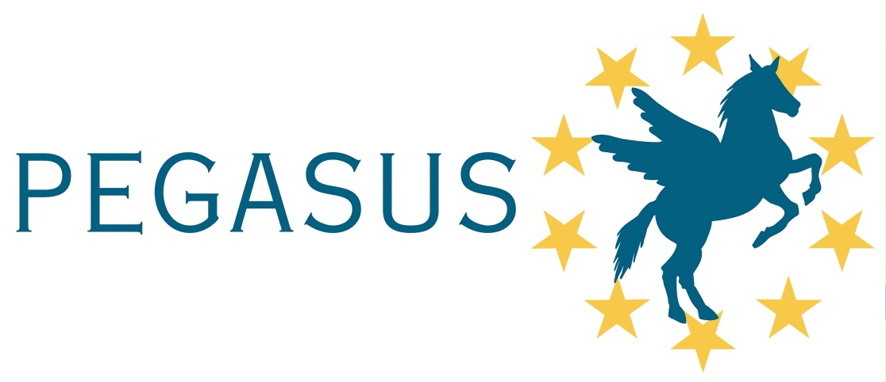

17th Pegasus
Student Conference
April, 2021

INTRODUCTION

The purpose of the conference is to provide a forum for PEGASUS Universities Students (i.e., students enrolled for a degree programme of PEGASUS institutions) and aerospace students of other European Universities to present technical papers in public competition for 1st, 2nd, and 3rd place in the graduate (masters candidates only) category. The conference serves to give the students an opportunity to practice the presentation of technical work at meetings.

The fundamental objective of the conference is to provide students with an educational experience that prepares them for their future as practicing aerospace engineers. Students attend and present technical work as they would at a professional meeting. In addition, they establish professional relationships, learn from others, and improve their communication skills. Their work, both written and oral, is evaluated by professional members serving as judges, with the primary intent of providing substantial feedback on the quality of their work. The highest scoring papers are also recognized with awards.

Any PEGASUS University Student or aerospace student of other European Universities is invited to participate in the conference. Only Masters’ level student papers are accepted for competition. Ph.D. student papers are not eligible to compete for awards. Their work may be presented for review only.

The work presented should be original, not already published or presented elsewhere.

Selected papers will be reviewed for publication in a special issue of Aerotecnica, a Springer Journal (https://www.springer.com/engineering/mechanical+engineering/journal/42496)

THE CONFERENCE CATEGORIES

Graduate Division (MS)
Papers based on independent student work (max. 2 students) that was part of any project completed in their final year (BAC+5 level) can compete in the Graduate Division of the Student Conference (examples could be the “projet de fin d’études” in France, the “tesi di Laurea Magistrale” in Italy, the “Studienarbeit” or “Diplomarbeit” in Germany). At the time of the Pegasus or AIAA conferences the students may have completed the diploma and even be working on an advanced degree (such as Ph.D.) but are still eligible for this graduate division based on work performed before they completed their diploma.

Subjects for student papers
All aerospace engineering disciplines are allowed (Aerodynamics, Gasdynamics, Heat Transfer, Structures, Materials, Aircraft Design, Subsystems and Integration, Rotary Wing Systems and Non-conventional Aircraft, Performance, Stability and Control, Flight Dynamics, Propulsion and Combustion, Production, Maintenance, Air Traffic Control, Aircraft Operations, Airports, Safety, Aircraft Navigation, Avionics, Communications, Space Engineering and Technology).

Official language
The official language of the conference is English. All papers must be written and presented in English.

Participation to International Student Conferences
The first place paper may be invited to participate in other International Student Conferences, such as the AIAA International Student Conference, typically held in January at the AIAA Aerospace Sciences Meeting & Exhibition in USA, or the International Conference on Aerospace for Young Scientists held annually in China.

BASIC PARTICIPATION RULES
The PEGASUS Student Conference represents the conclusion of a competition or selection that every PEGASUS institution or European Aerospace University can implement locally.
All students of a PEGASUS institution or aerospace students of other European Universities are invited to participate, proposing their paper to their own institution.
Each institution will pre-select, adopting self-given criteria, a maximum of three papers for the conference and also make sure that the submitted contributions satisfy the rules for the event. The papers selected will actually participate in the PEGASUS Student Conference.
No travel costs of the students to the PEGASUS Student Conference location can be supported by the organization of the latter.
Non-PEGASUS Universities will be asked to participate actively in the Organizing and Judging Committees, should their affiliate students send any paper.

DEADLINE FOR STUDENTS OF THE UNIVERSITY OF STUTTGART

Students graduated at the University of Stuttgart after April 2020 are entitled to participate. They should send all required documents (full paper and application form) before February 1, 2021 to the attention of bjoern.annighoefer@ils.uni-stuttgart.de.

VENUE
The 17th Pegasus student conference will be held at in April 2021. For further details, consult the PEGASUS website (www.pegasus-europe.org). At the moment we cannot yet tell whether the conference will be a physical, hybrid or fully online conference.

